

NATIONAL UNIVERSITY OF TECHNOLOGY
(Department of Computer Science)
CS161– Database Systems
Instructor: Noushin Saba
Name: Bisma Fatima
Roll no: f24605036

LAB TASK 04

INLAB TASK
Task 1
• Create Database with the Name UniversityDB.
• Create a Collection for Departments
• Create a Collection for Courses
FIGURE
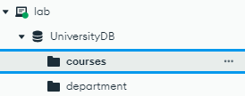
Task 2
• Insert documents with following attributes:
1. Applied Computing (ACS)
• Location: 3D07
• Phone: (204) 786-0300
• Chair: Simon Lee
• Courses Offered:
- 1453: Introduction to Computers (3 Credit Hours)

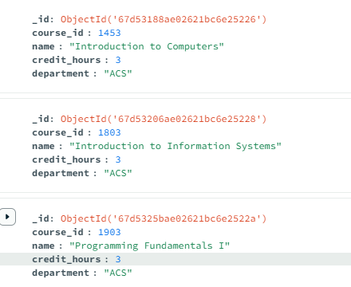

- 1803: Introduction to Information Systems (3 Credit Hours)



- 1903: Programming Fundamentals I (3 Credit Hours)


- 1904: Programming Fundamentals II (3 Credit Hours)

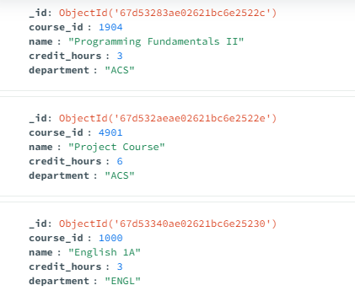

- 4901: Project Course (6 Credit Hours)

OVERALL
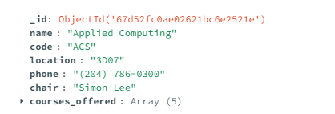

2. English (ENGL)
• Location: 3D05
• Phone: (204) 786-9999
• Chair: April Jones
• Courses Offered:
- 1000: English 1A (3 Credit Hours)

- 1003: Introduction to English: Topics in Literature (3 Credit Hours)

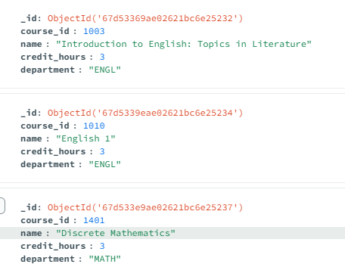

- 1010: English 1 (3 Credit Hours)


OVERALL
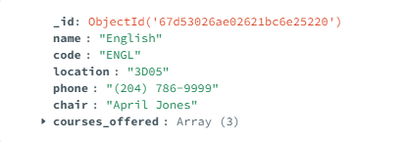

3. Mathematics (MATH)
• Location: 2R33
• Phone: (204) 786-0033
• Chair: Peter Smith
• Courses Offered:
- 1401: Discrete Mathematics (3 Credit Hours)



OVERALL
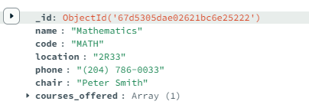

Post LAB TASK
Task 1
Instead of storing courses separately, modify the Departments collection to include an array of Courses inside each department document.
• Store all English department courses inside the English department document.
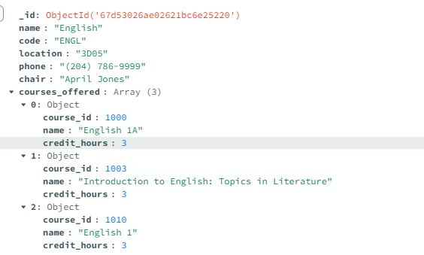
• Store all Applied Computing courses inside the ACS department document.
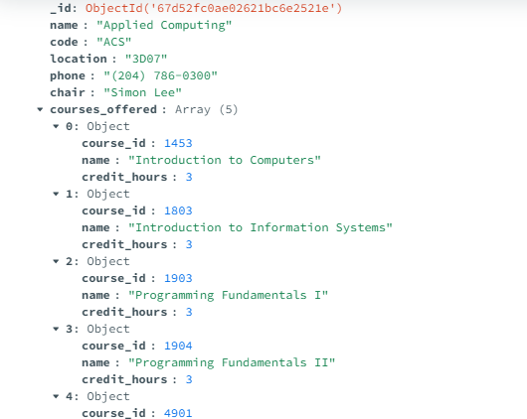
• Store all Mathematics courses inside the mathematics department document.
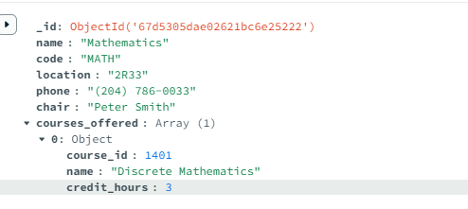

Lifelong Learning Component
How can the skills learned in creating databases, collections, and inserting documents in MongoDB be applied to real-world applications beyond university course management? Provide an example from a different industry, such as logistics or social media, and explain how continuous learning in NoSQL databases helps professionals adapt to evolving data structures, optimize performance, and enhance decision-making.
Answer:

Skills in creating MongoDB databases, collections, and inserting documents are highly transferable to real-world applications. For example, in logistics, MongoDB can manage real-time shipment tracking, route optimization, and inventory management. Collections like `shipments`, `routes`, and `inventory` store dynamic data, enabling efficient operations and decision-making.

Continuous learning in NoSQL databases helps professionals:

Adapt to evolving data structures by leveraging MongoDB’s flexible schema.

Optimize performance through indexing, sharding, and aggregation pipelines.

Enhance decision-making by analyzing diverse data types for actionable insights.

These skills are also valuable in industries like social media (user data management), healthcare (patient records), and e-commerce (product catalogs), ensuring scalability, efficiency, and innovation.

